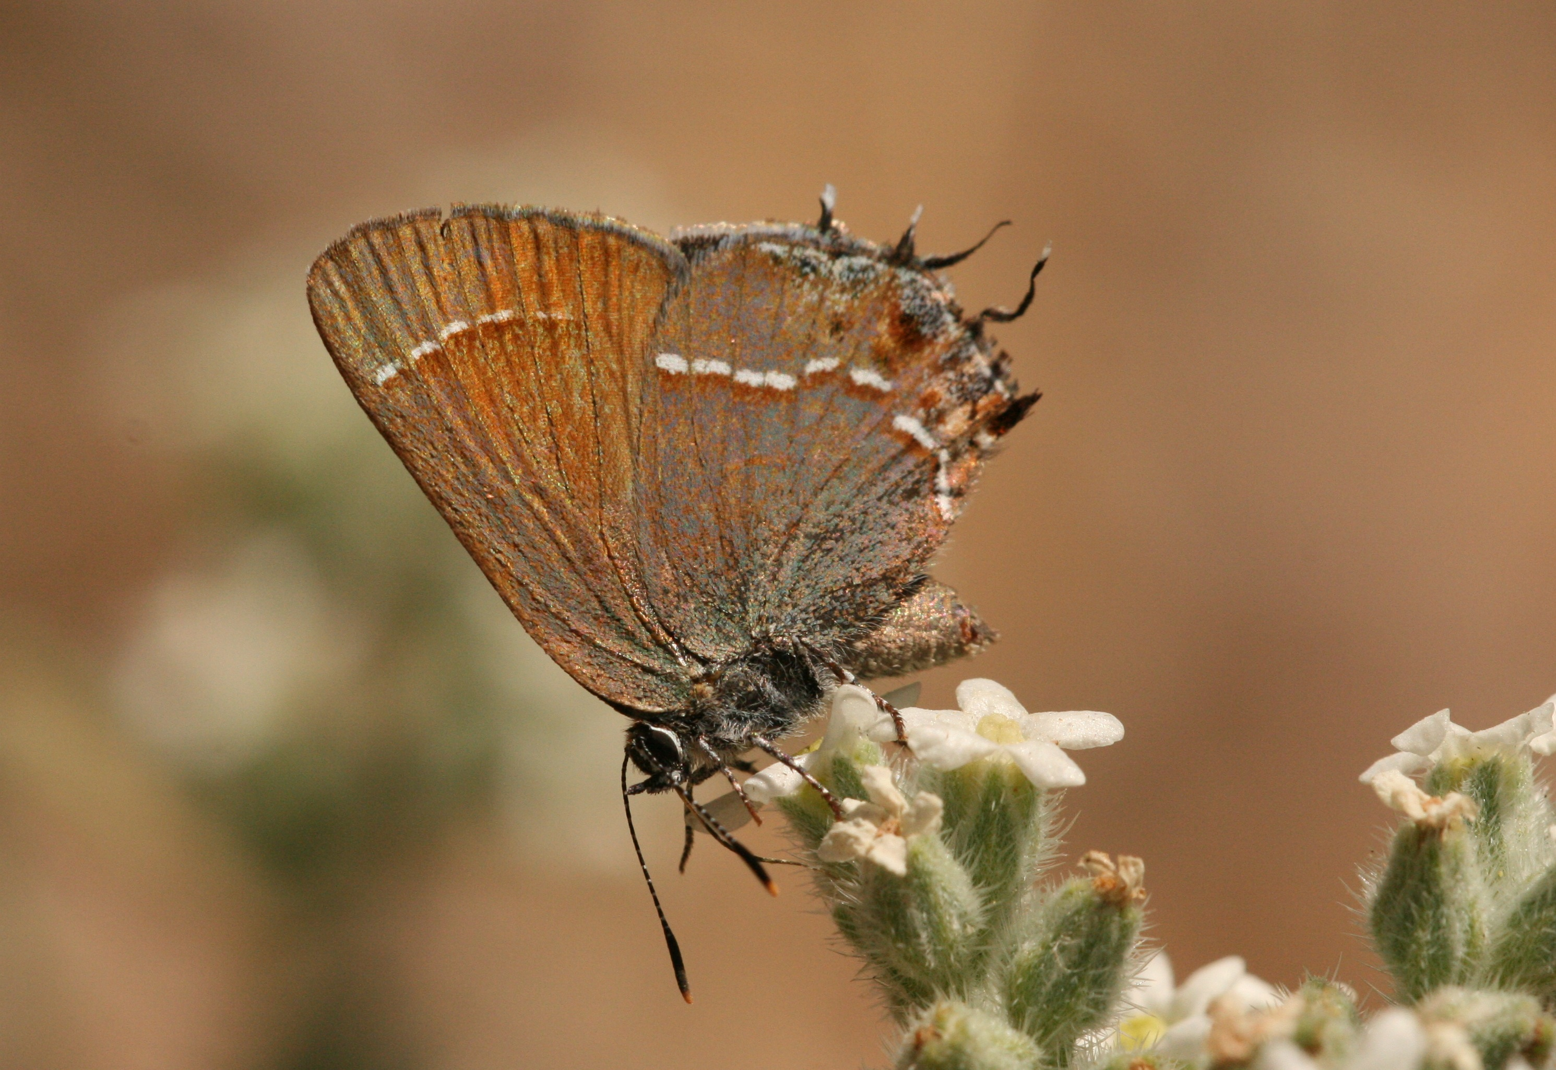**Please do not enter meadow, pollinator survey in processes**

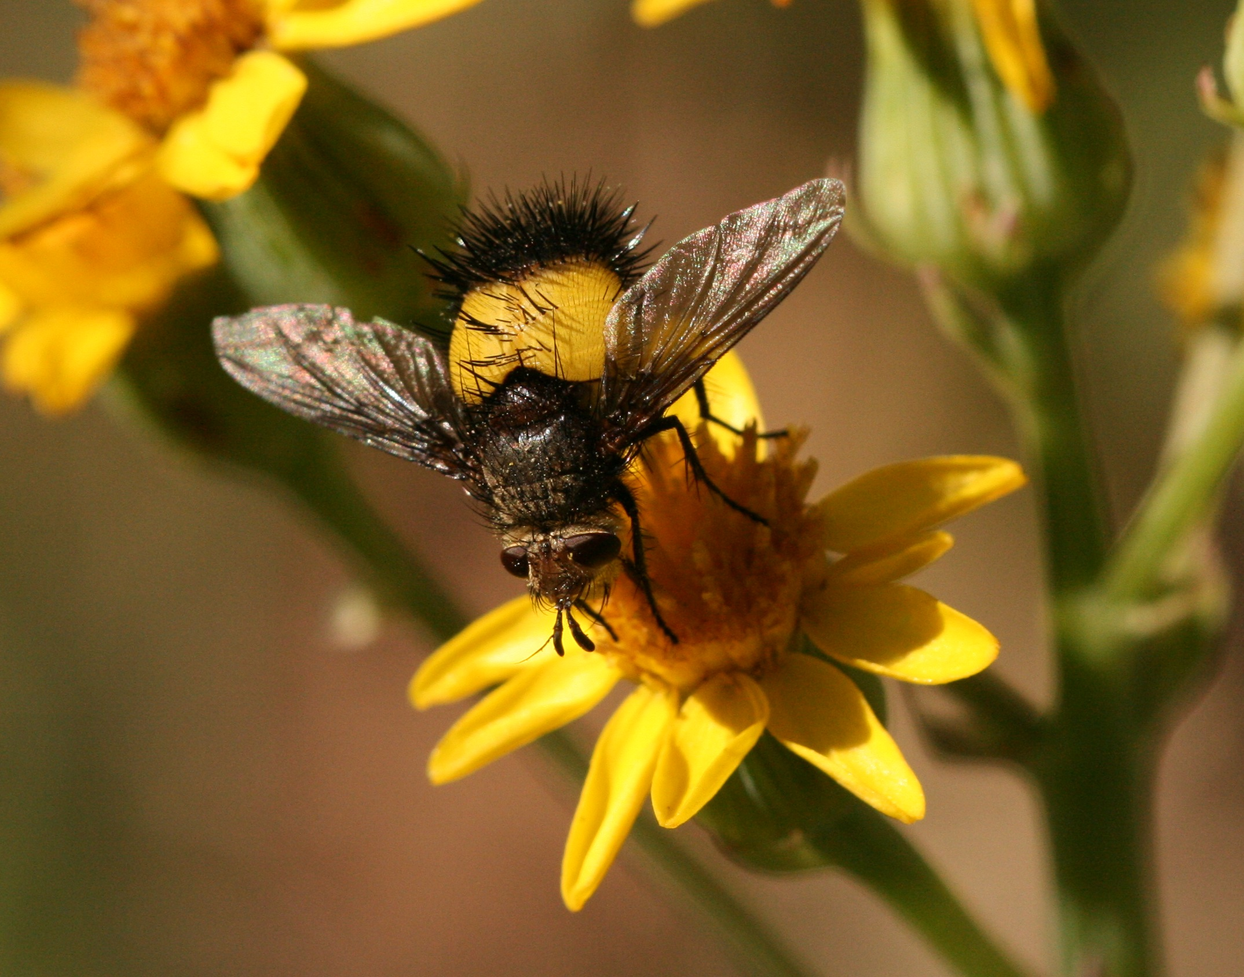We are conducting a survey of the pollinators such as hummingbirds, bees, flies, butterflies and moths and their interactions with flowering plants in this. Often to effectively preserve a community we must protect not only the species present but also the interactions between species.

Hairstreak, Peloncillo meadows

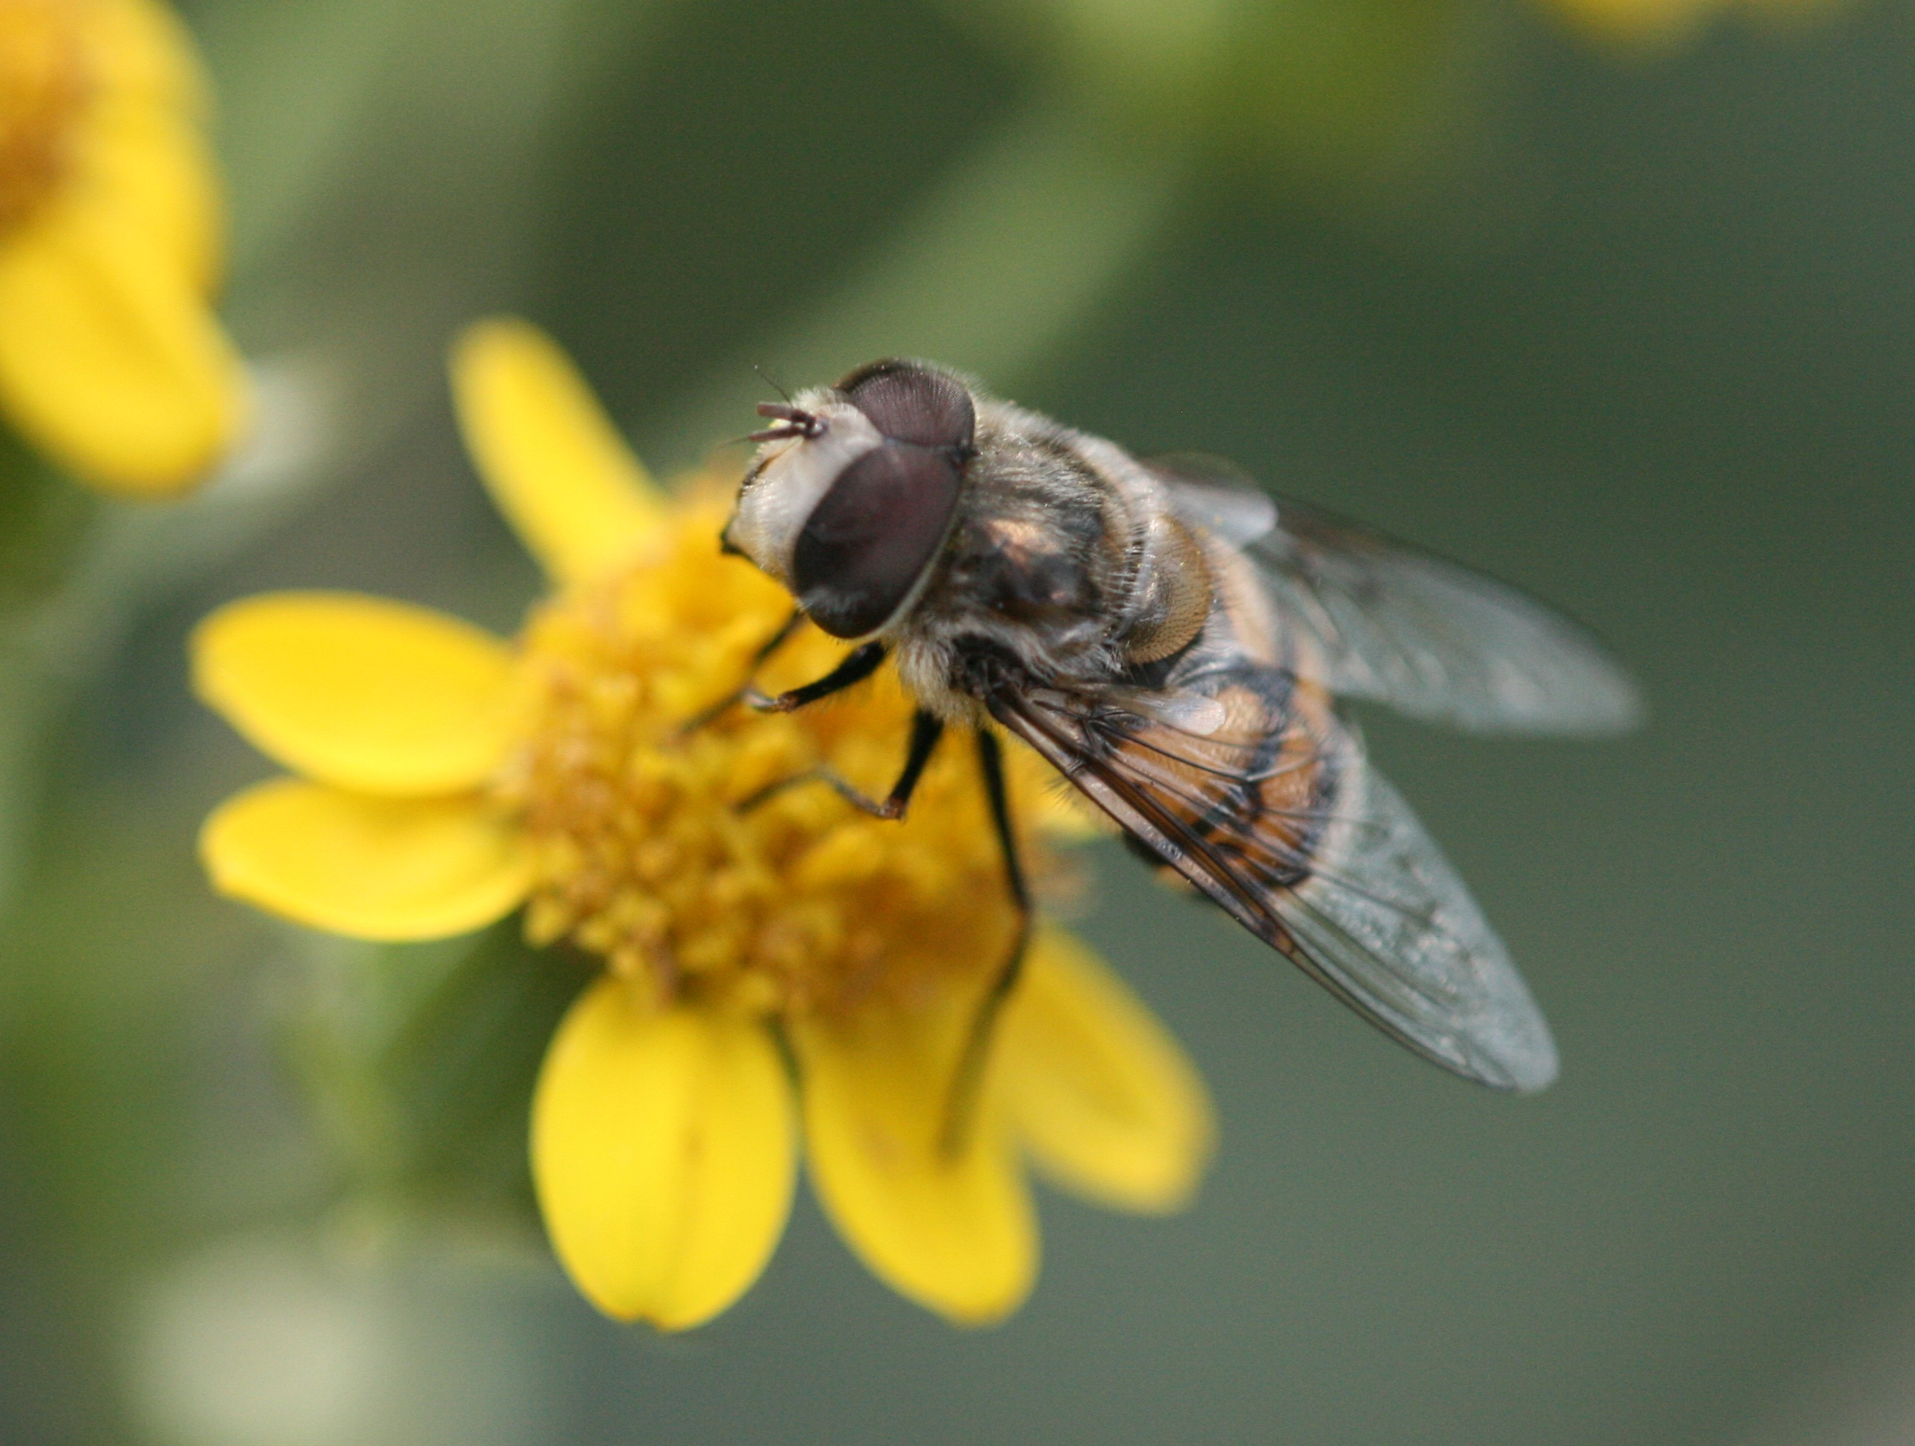High elevation meadows contain a staggering number of pollinator and plant species. Often these plants and pollinators are present only on a specific mountaintop. For example the Mt. Washington beardtongue (*Penstemon pseudoparvu****)*** is only foundin the Magdalenas and Mt. Washington and Cockerell’s bumblebee (*Bombus cockerelli*) has the most limited range of any bumblebee species in the world and is found only in the White Mountains.

Bumblebee mimic fly, Chiricahua meadows

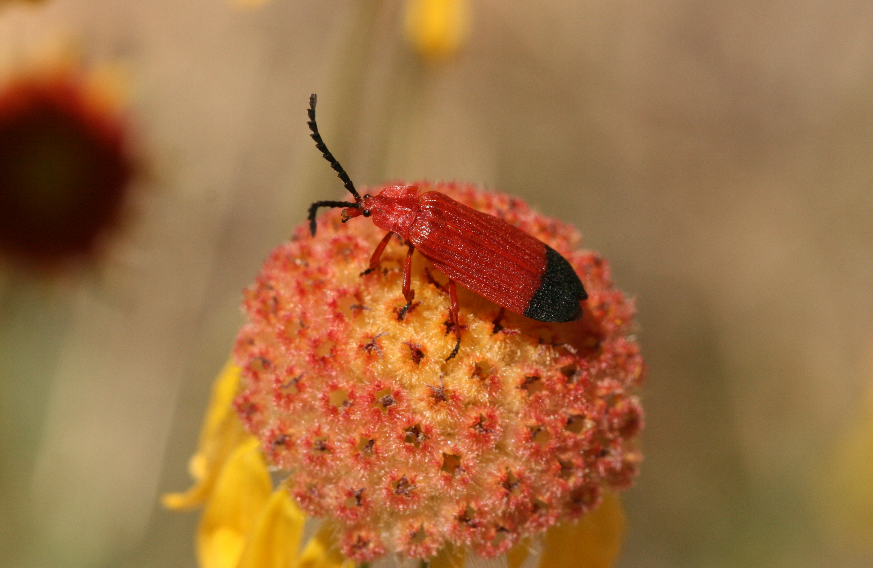These high elevation meadows are formed by a rare combination of soil texture and moisture that inhibits the growth of trees. Because so many factors need to be just right for a meadow to persist, there are generally very few in any one mountain range. Additionally, meadows in the southwest and nationally are disappearing due to development for housing or campsites, stock grazing and other human impacts.

Hoverfly, Chiricahua meadows

Please respect meadow closure notices because they are in place to protect these beautiful places for the enjoyment of future generations and for the wildlife that rely on the resources the meadows provide.

Net-winged beetle, Peloncillo meadows